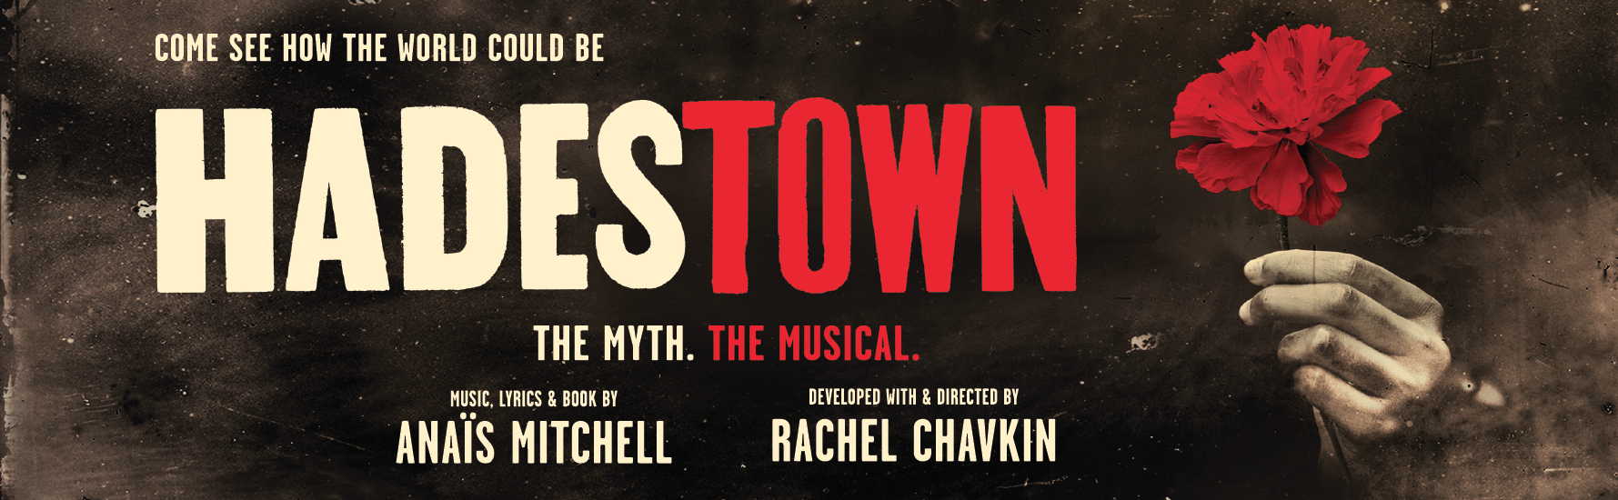
Copy for Tour (updated 6/26/20)

Note: The “come see how the world could be” tagline is also included in many title lockups. It should only appear once in each placement, wherever it will be most legible, and may be eliminated from the second placement.

LONG (143 words)
COME SEE HOW THE WORLD COULD BE.

Welcome to HADESTOWN, where a song can change your fate. Winner of eight 2019 Tony Awards® including Best Musical and the 2020 Grammy® Award for Best Musical Theater Album, this acclaimed new show from celebrated singer-songwriter Anaïs Mitchell and original director Rachel Chavkin (Natasha, Pierre & The Great Comet of 1812) is a love story for today... and always.

HADESTOWN intertwines two mythic tales — that of young dreamers Orpheus and Eurydice, and that of King Hades and his wife Persephone — as it invites you on a hell-raising journey to the underworld and back. Mitchell’s beguiling melodies and Chavkin’s poetic imagination pit industry against nature, doubt against faith, and fear against love. Performed by a vibrant ensemble of actors, dancers and singers, HADESTOWN is a haunting and hopeful theatrical experience that grabs you and never lets go.

MEDIUM (101 words)
COME SEE HOW THE WORLD COULD BE.

Welcome to HADESTOWN, where a song can change your fate. Winner of eight 2019 Tony Awards® including Best Musical and the 2020 Grammy® Award for Best Musical Theater Album, this acclaimed new show from celebrated singer-songwriter Anaïs Mitchell and original director Rachel Chavkin (Natasha, Pierre & The Great Comet of 1812) is a love story for today... and always.

Intertwining two mythic tales — that of young dreamers Orpheus and Eurydice, and that of King Hades and his wife Persephone — HADESTOWN is a haunting and hopeful theatrical experience that grabs you and never lets go.

SHORT (51 words)
COME SEE HOW THE WORLD COULD BE.

Welcome to HADESTOWN, where a song can change your fate. Winner of eight 2019 Tony Awards® including Best Musical and the 2020 Grammy® Award for Best Musical Theater Album, HADESTOWN is a haunting and hopeful theatrical experience that grabs you and never lets go.

REASONS TO SEE IT

Winner of eight 2019 Tony Awards® including Best Musical and the 2020 Grammy® Award for Best Musical Theater Album

From celebrated singer-songwriter Anaïs Mitchell and original director Rachel Chavkin

Haunting and hopeful, a love story for the ages

An unforgettable story and score, beautifully staged and performed

