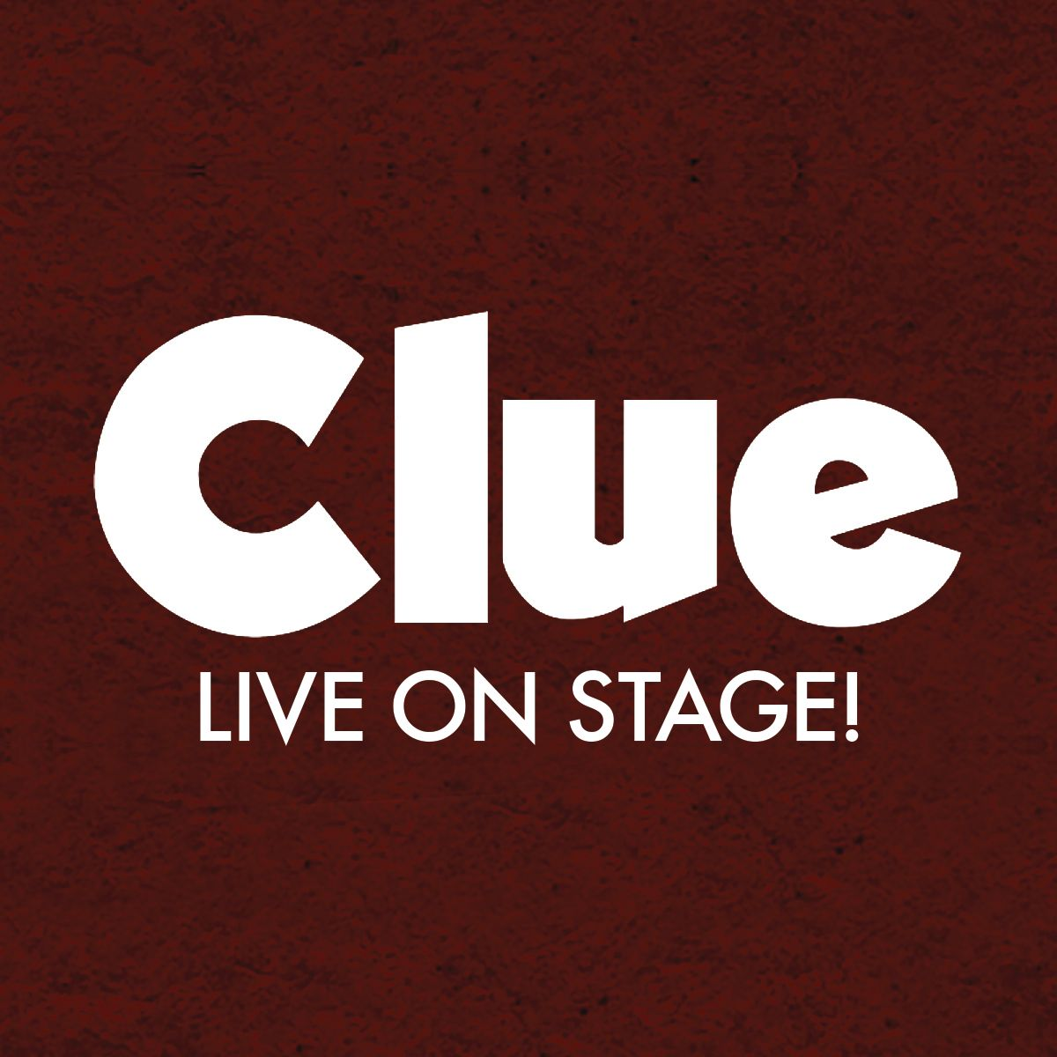

**CLUE Copy**

*Recommended (77 words):*

**A mansion. A murder. A mystery.**

Murder and blackmail are on the menu when six mysterious guests assemble at Boddy Manor for a night they’ll never forget! Was it Mrs. Peacock in the study with the knife? Or was it Colonel Mustard in the library with the wrench? Based on the fan-favorite 1985 Paramount Pictures movie and inspired by the classic Hasbro board game, *Clue* is the ultimate whodunit that will leave you dying of laughter and keep you guessing until the final twist.

*Short copy (56 words):*

Murder and blackmail are on the menu when six mysterious guests assemble at Boddy Manor for a night they’ll never forget! Based on the fan-favorite 1985 Paramount Pictures movie and inspired by the classic Hasbro board game, *Clue* is the ultimate whodunit that will leave you dying of laughter and keep you guessing until the final twist.

*Hasbro Legal Billing:*

**©2024 Hasbro. All rights reserved.**

* To be included on all venue websites on your *Clue* event page

*Quotes:*

“A very fun whodunit that strikes contemporary parallels on the way to its grand reveal.”

*- The New York Times*

“Reminds you what a breezy night of pure entertainment feels like.”

*-TheatreMania*

“Extraordinarily entertaining.”

*-Broadway World*

“An intriguing must-see production”

*- Broadway World*

“The staging is inspired… fast-paced, twisty dialogue – ripe with double entendres – and broad physical humor.”

*- The Plain Dealer*

“Finds just the right balance of slapstick and drama.”

*- The Plain Dealer*

“Clue: Live on Stage!” earns its exclamation point through the breathless exuberance of its physical comedy.

–[*Los Angeles Times*](https://www.latimes.com/entertainment-arts/story/2024-08-01/clue-ahmanson-review)

“It’s funny and frothy and light, the kind of breezy night at the theater that most audiences would kill for right now”

*-* [*Entertainment Weekly*](https://ew.com/clue-live-on-stage-review-ahmanson-theatre-8687669)

Really digs into the farcical, slapstick elements of the movie with great success

[*- The Washington Post*](https://www.washingtonpost.com/entertainment/theater/2024/09/19/clue-live-on-stage-tour-kennedy-center/)

Delish! The one-liners fly fast and furious with pitch-perfect rapid-fire comedic timing and bursts of side-splitting slapstick.

*-* [*Stage Scene LA*](https://stagescenela.com/2024/08/clue-live/)

'Clue' is a superbly acted whodunit that aims to entertain.

*-* [*WBUR NPR Boston*](https://www.wbur.org/news/2024/05/02/broadway-in-boston-clue-theater-review)

There’s an infectious quality to the knockabout antics

– [Los Angeles Times](https://www.latimes.com/entertainment-arts/story/2024-08-01/clue-ahmanson-review)

"Clue" is filled with rapid banter, slapstick comedy and enthralling special effects.

*-* [*The Post-Crescent*](https://www.postcrescent.com/story/entertainment/theater/2024/03/20/review-clue-is-dark-slapstick-comedy-with-exceptional-comedic-acting/73031692007/)

“Clue is Devilishly Fun”

*–* [*The Stage of MN*](https://thestagesofmn.com/2024/02/28/clue-is-suspiciously-familiar-but-devilishly-fun-running-through-march-3rd-at-the-orpheum/)

"Clue" has its own unique soundtrack ― the constant audience laughter that filled the theater. - [*Louisville Courier Journal*](https://www.courier-journal.com/story/entertainment/theater/2024/03/06/pnc-broadway-in-louisville-clue-review-at-kentucky-center/72788472007/)

Eighty minutes of nonstop whodunit hilarity

*-* [*Stage Scene LA*](https://stagescenela.com/2024/08/clue-live/)